Output Of Event Management App

1.When we run our program

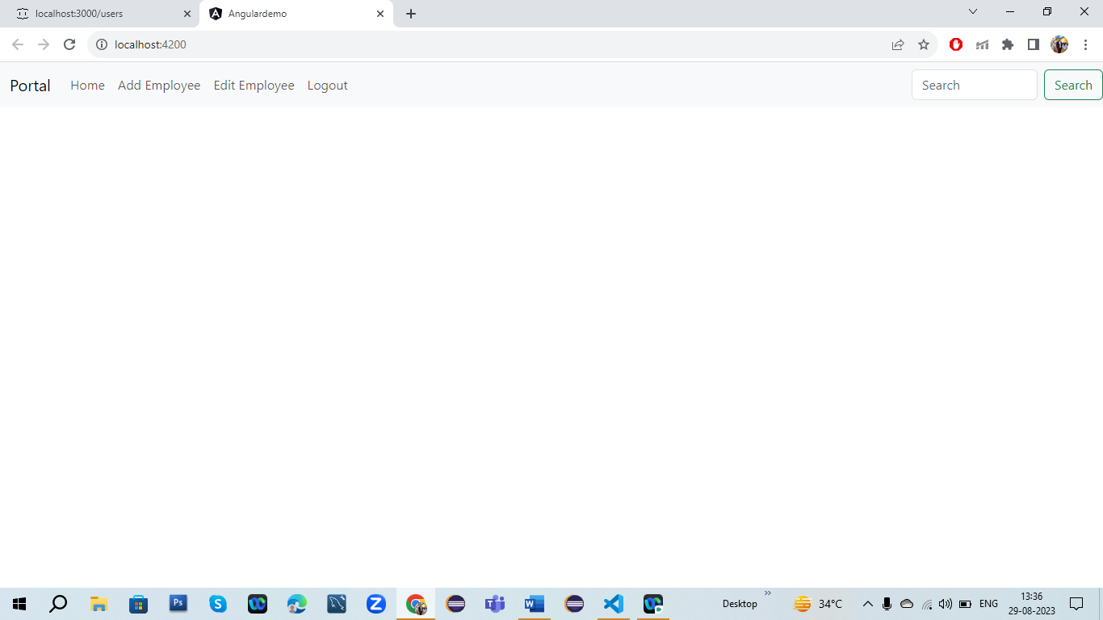

2.When we click on Add Employee

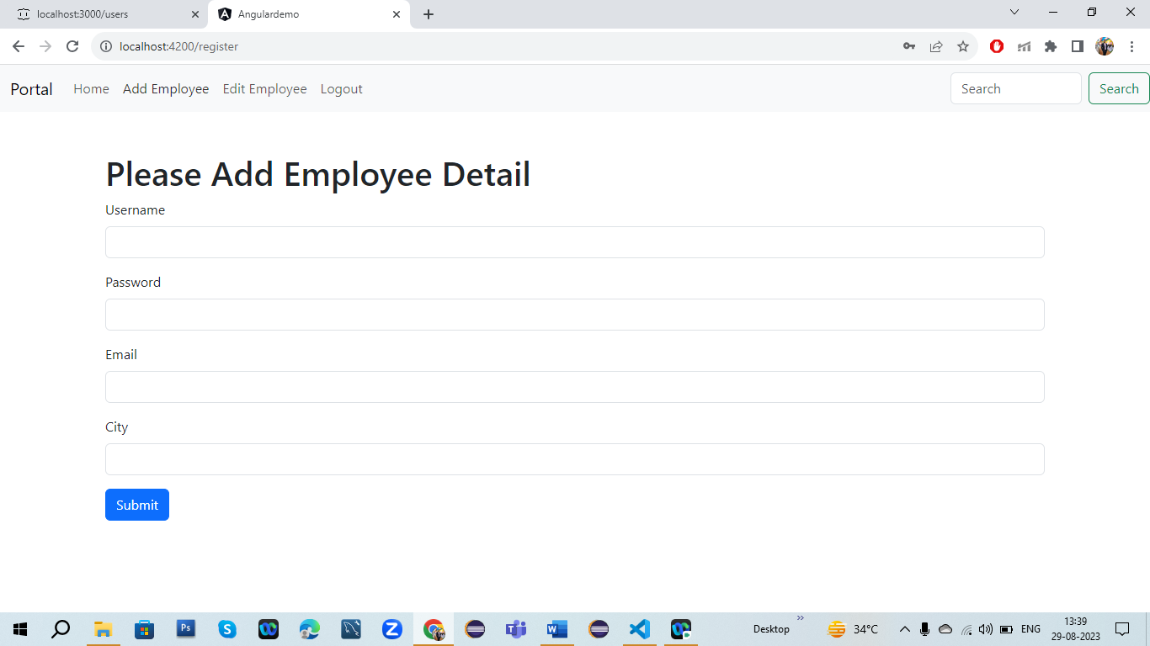

3.After adding Employee we see our detail in json server

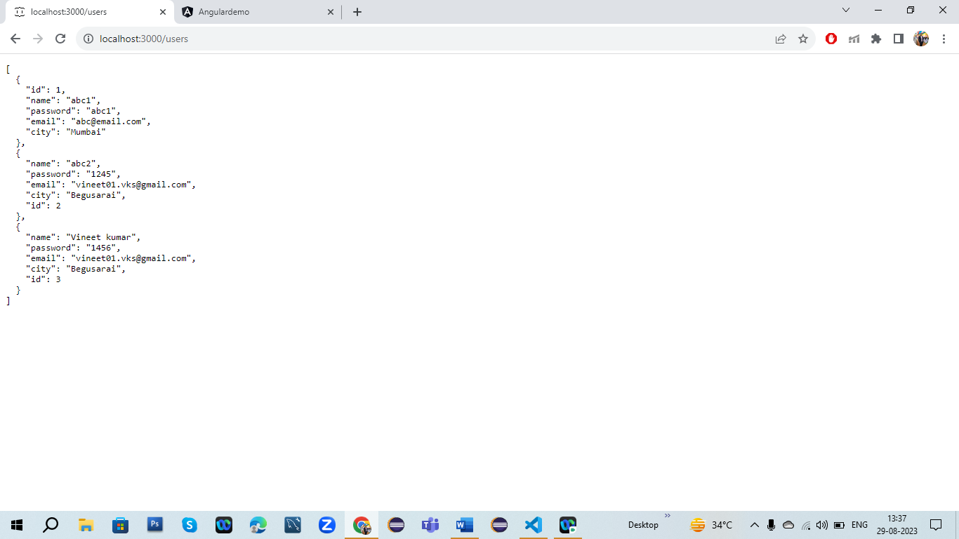

4.When we click on Edit Employee

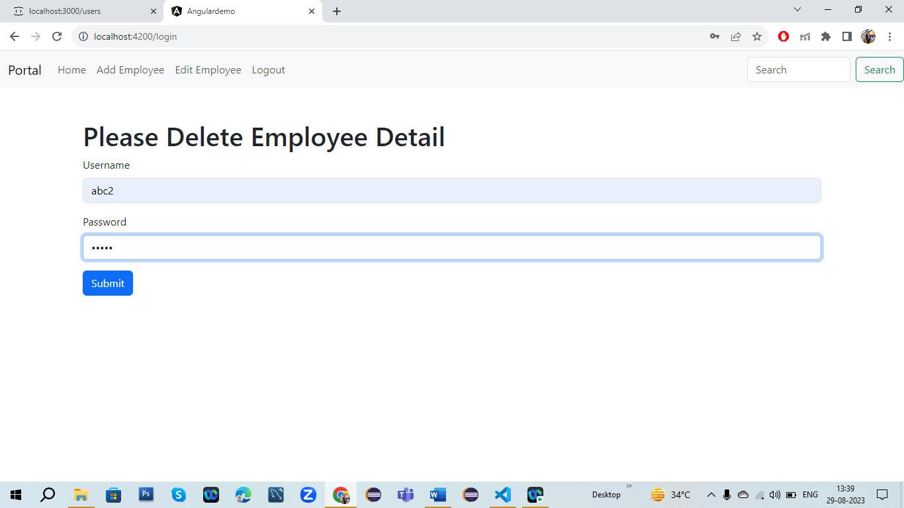

5.After submit for deleting data of employee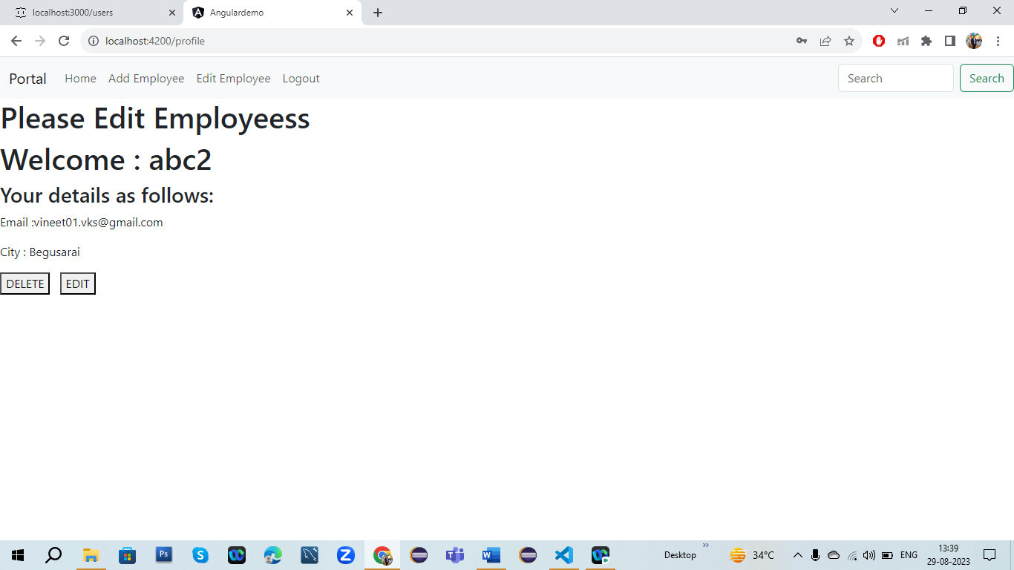

6.Then click on edit button to edit employee detail what you want

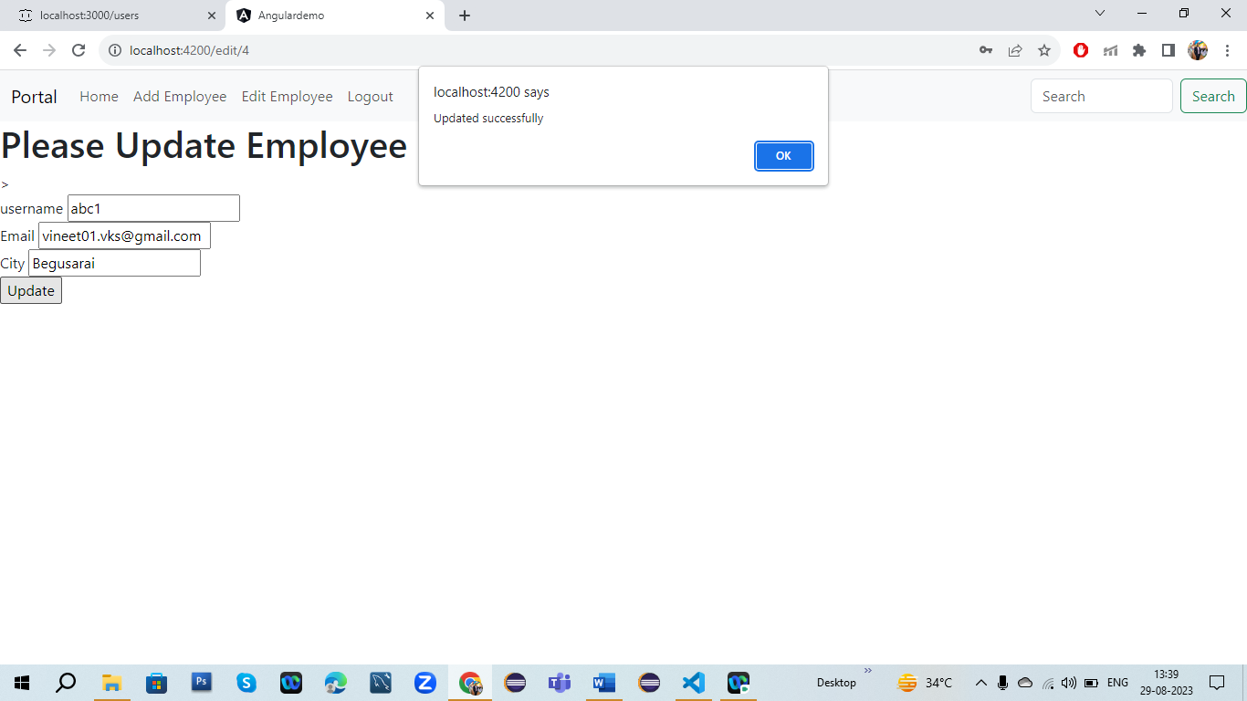

7.After editing the employee detail json server of output is

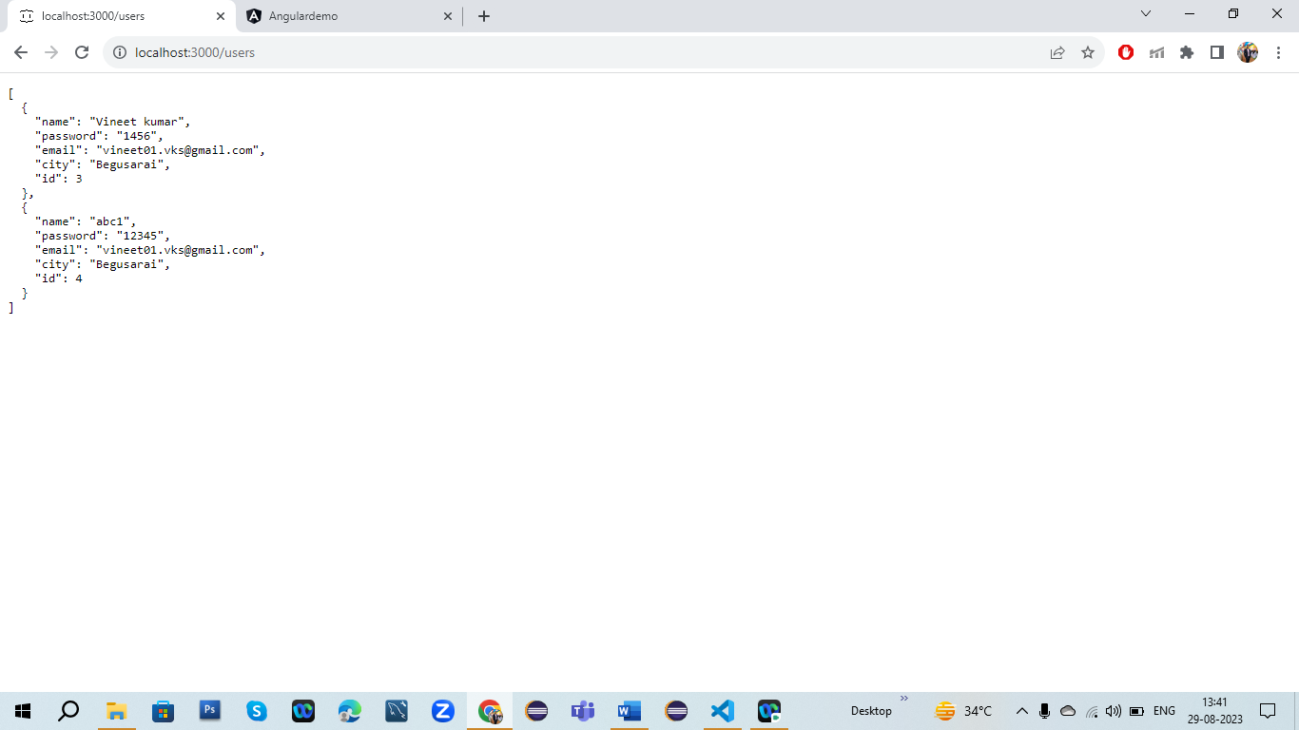

8.Then After clicking on delete button for deleting employee data

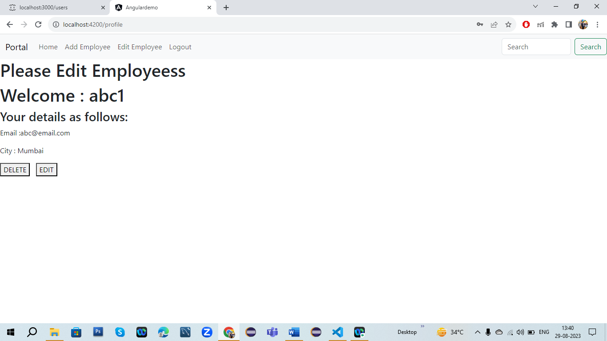

9.Then output is

